



EMM6

Laser Device data Integration Test Report

From Javra Software B.V.

Date: 9 december 2015

Version: 1.0

1. **Introduction:**

This document is related to the today (11/12/2015) test session. It covers all outcomes of the data integration process.

1. Data Integration Success Outcomes

This was our first Test of new laser data integration from our Ems system. We faced little bit difficulties and Unexpected Pop-up messages. We hope you all understand the circumstances.

As we all know that, the main motto of our today session was to get the data from the laser controller and store in to the specified location. Then analyze the data in the Ems system so that we can put the maximum value of the fields to the database table.

1. **Get the data from the laser controller and store in to the specified location.**

Yes, we successfully got the data from the laser controller, and we stored in the Predefined location. For more clarification, you can check on below Images.

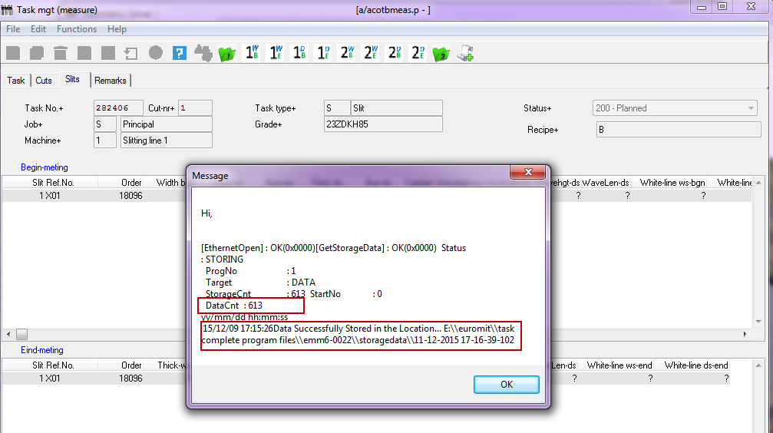

**Stored files are:**

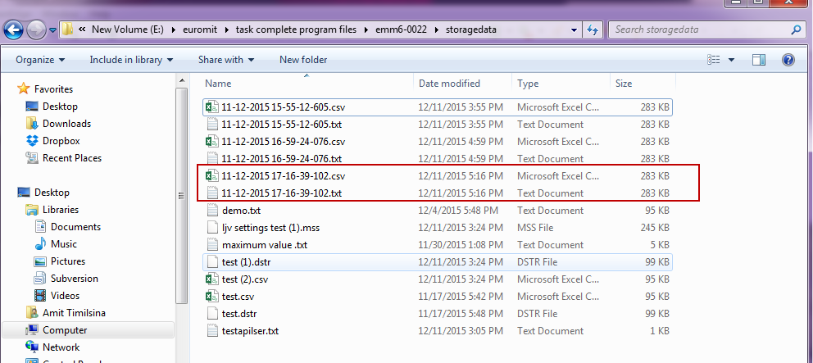

**Note:** **But while Testing Error Message occurred “Entry 2 outside the range”, this is because of problem on the data to read from the location.**

**B. Get maximum value and put on the defined location.**

We did not read file, so that we could not get the max data, after that all the process were lost. We researched on the Failure of this step and we found 2 Problems on the saved file.

1. On the basis of previous Session files (17 Nov test session), we assumed that data will come with Semicolon separator (;) that’s why we prepared logic to separate the different fields data on the basis of semicolon. Which was failed today.
2. On the basis of previous Session files (17 Nov test session), if setting in the laser device not changed, we assumed that data will come always at the same pattern and It will be have head also.

**Eg: Time to strg; OUT1; OUT2; OUT3; OUT4.**

Today Data was came with different format (Mismatched columns and no headers).

**Old Data and its Format:**

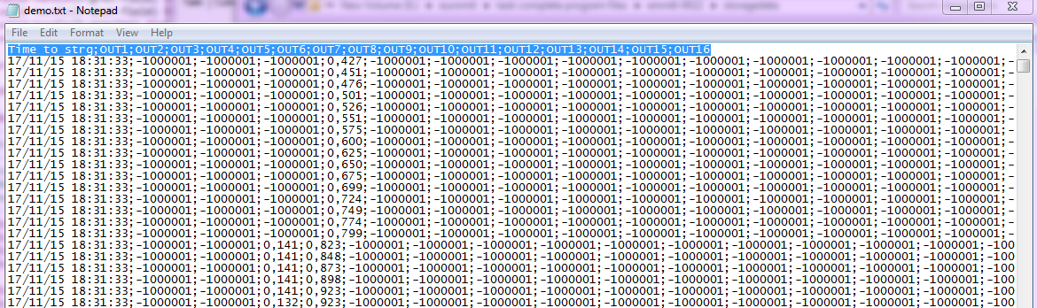

**New Data and its Format:**

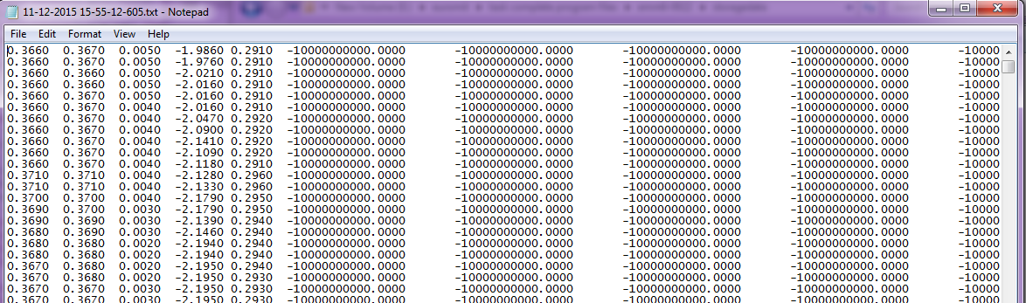

**Above these reason we were not able to get max value from the file.**

1. **Future Modification:**

In coming days, we will fetch the data on the basis of header name, So that we can get required data from any columns whether it is any location of the file.

**Note: For above all process, we need fixed format of data in the file, if data separation (“;”, Tab, space, etc.) is changed in future, it will affect our program logic.**